**Sheet No : 03**

**Assignment No : 07**

1. **Create a view of all students in dept CSE:**

**Query:**

create view cse_stud as

select *

from students s

where s.deptcode = 'CSE';

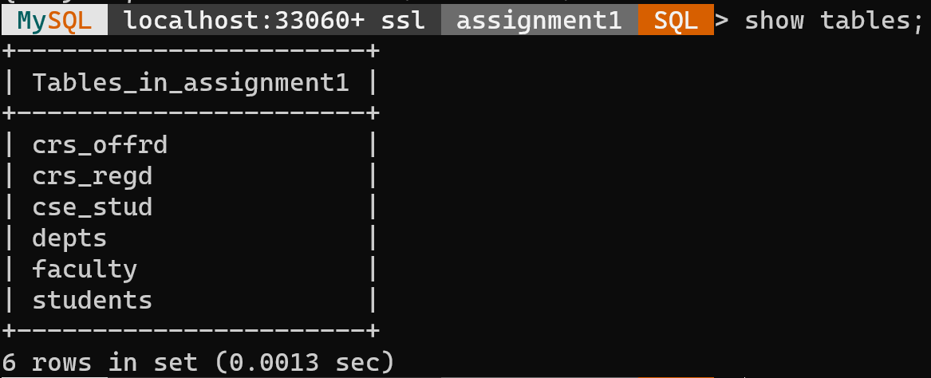

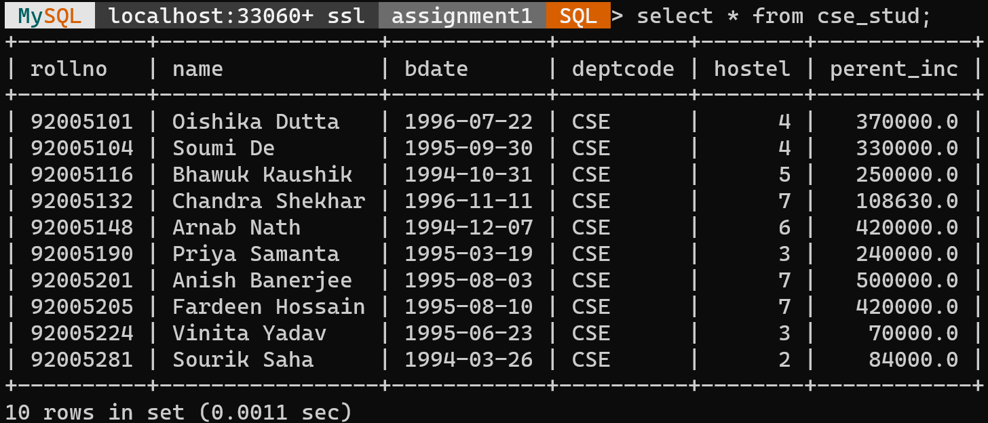

1. **Create a view named as cse_stud for ‘CSE’ dept students having attributes rollno, name, hostel.**

**Query:**

create or replace view cse_stud as

select s.rollno, s.name, s.hostel

from students s

where deptcode = 'CSE';

**Output:**

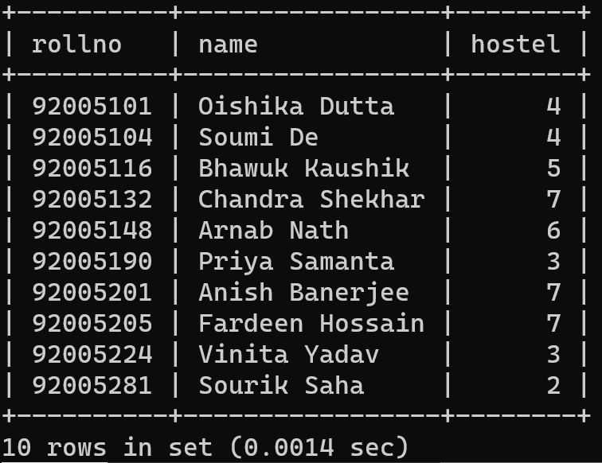

1. **Insert a new student of CSE. Analyse the result.**

**Query:**

insert into cse_stud values (92005169, 'Anudeep', 7);



The new inserted value is not present in cse_stud view. However, this is present in students table but bdate, deptcode and perent_inc are NULL.

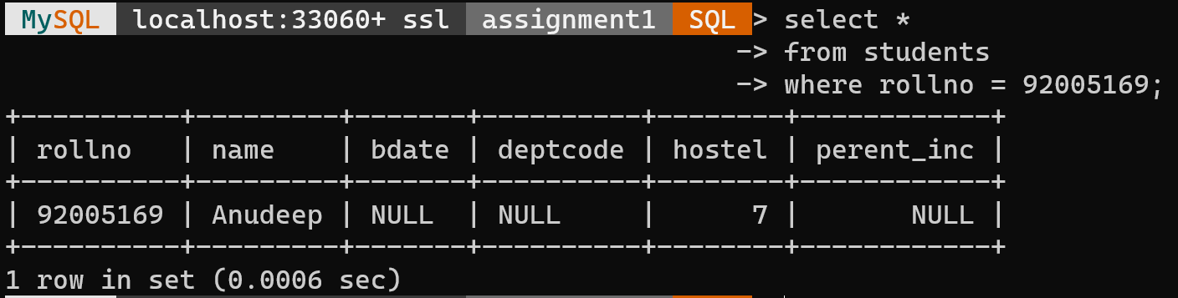

1. **Increment parental income by Rs. 5000 (HRA).**

We created a new view named cse_stud_inc to increment the parental income as we cannot alter the parental income from cse_stud table as perent_inc column is absent there.

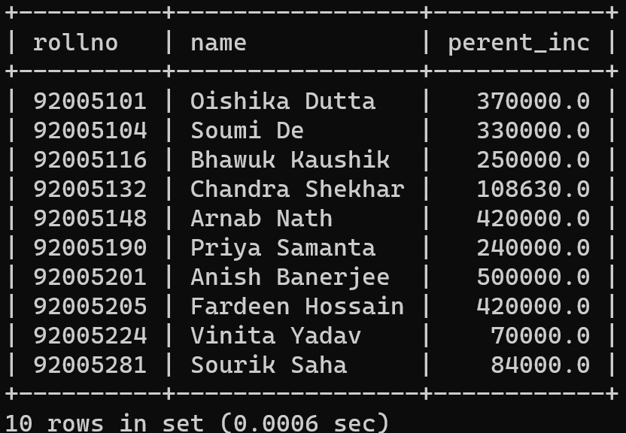

**Query:**

update cse_stud_inc

set perent_inc = perent_inc + 5000;

**Before:**



**After:**

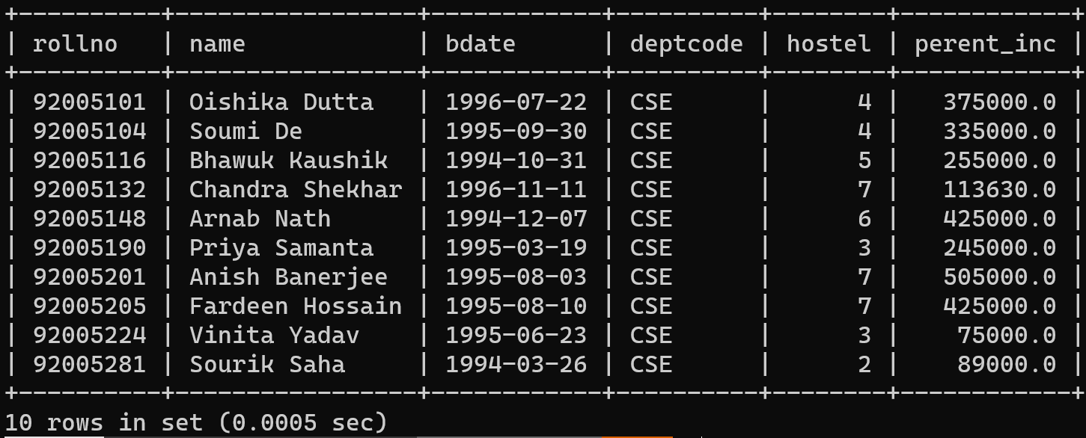

This also makes changes in the students table.

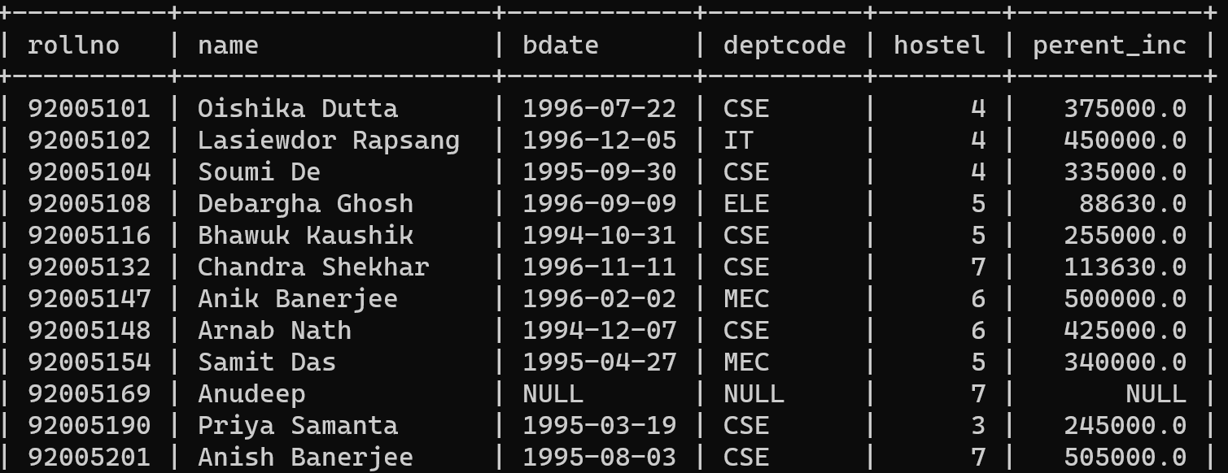

1. **Delete the view.**

**Query:**

Drop view cse_stud;

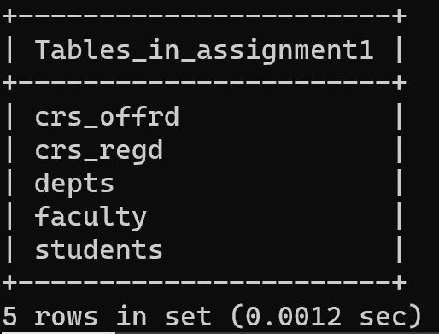

**Observation :**

cse_stud view is deleted. students table retains the update.

**Part – 2**

1. **Create another view of all students in dept Mechanical Engineering (department Name).**

**The view will contain attributes namely Roll-No, Name, Department Name, Age.**

**Query:**

create or replace view me_stud as

select s.rollno, s.name, s.deptcode, s.bdate

from students s where s.deptcode = 'MEC';

**Output:**

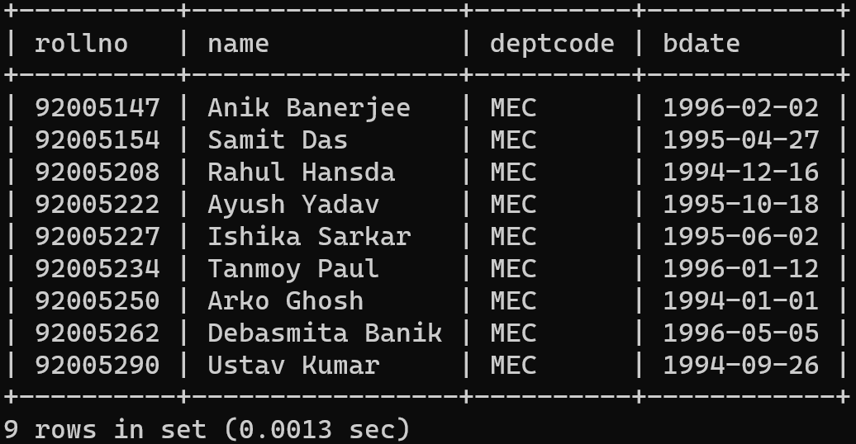

1. **Insert a new student of Mechanical Engineering Department.**

**Query:**

insert into me_stud values (92005280, ‘Triparno Mondal’, ‘MEC’, ‘1995-08-18’);

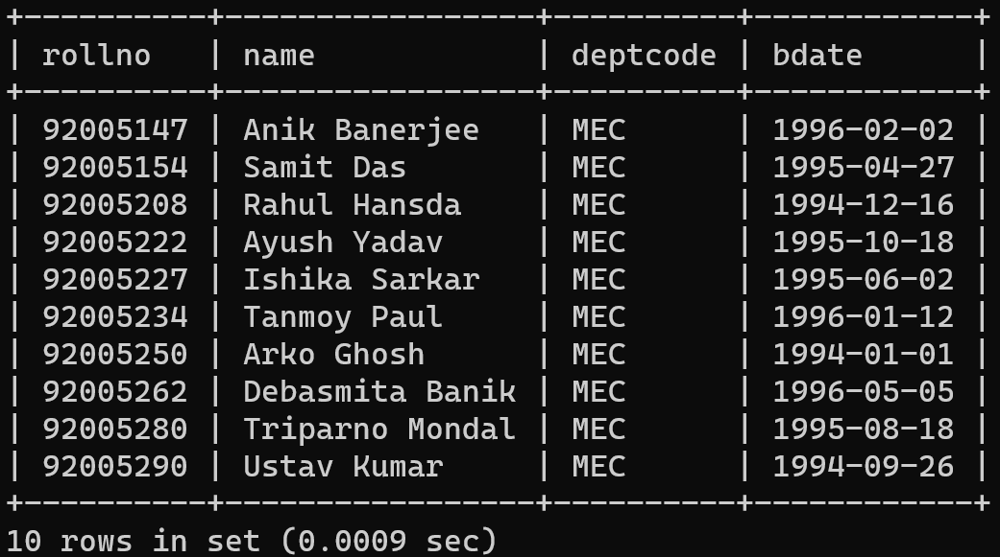

No record shows in the view me_stud. However, it is added in the students table with hostel and perent_inc having null values.

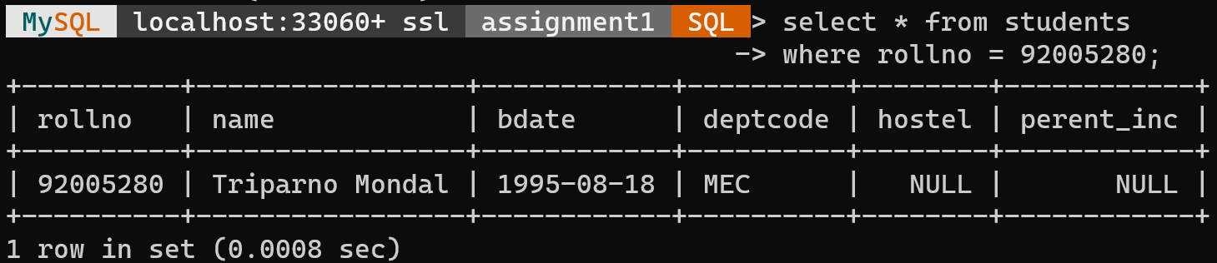

1. **Delete a student (for a given Name) of the same department.**

**Query:**

delete from me_stud

where rollno = 92005234;

**Before:**



**After:**

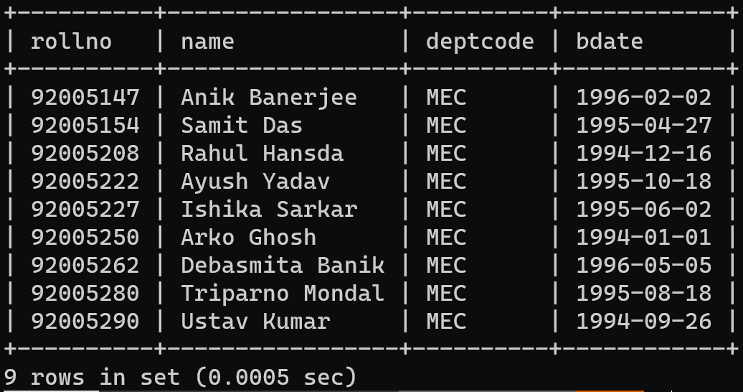

Tuple also got deleted from the students table.

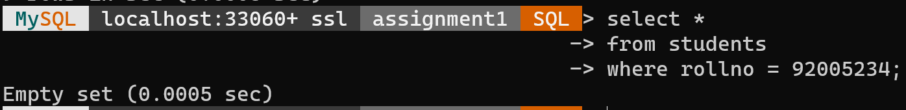

1. **Shift a student (for a given Name) from Mechanical to Computer Science.**

**Query:**

update me_stud

set deptcode = ‘CSE’

where rollno = 92005154;

**Before:**



**After:**

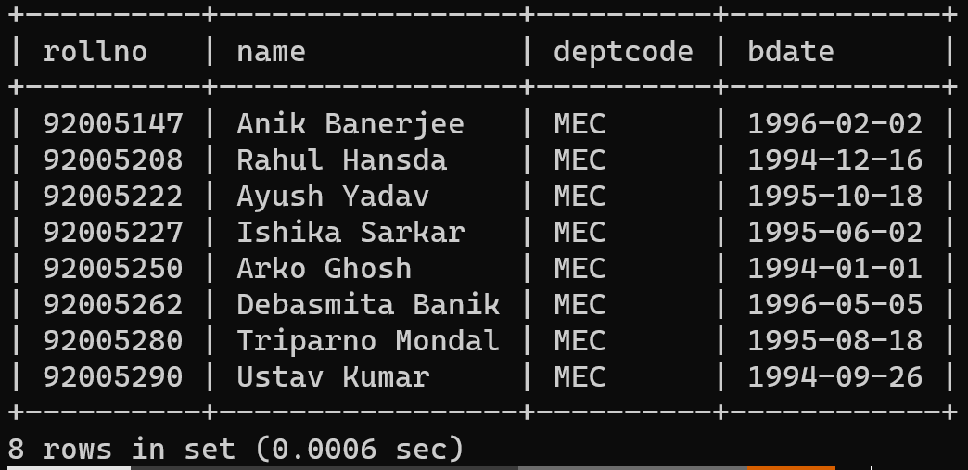

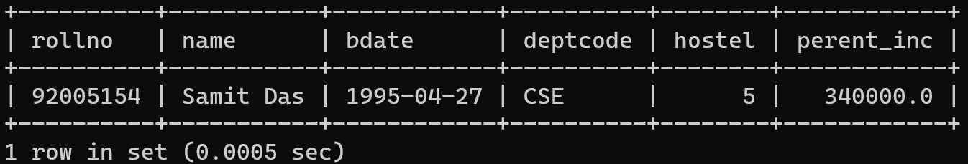

**Inferences:**

**1.** I noticed that when attempting to insert new students directly into the cse_stud view, the inserted data did not appear in the view. This is because views in MySQL are typically read-only and do not store data. To have the data reflected in the view, it needed to be inserted into the underlying table (students).

**2.** I successfully updated the cse_stud_inc(another view which has perent_inc as a column) view to increment parental income by Rs. 5000, and this update also affected the underlying students table. This illustrates that views are closely tied to the base tables and changes in views propagate to the base tables.

**3.** Deleting the cse_stud view was straightforward, and it did not impact the underlying table (students).

**4.** I created another view named me_stud for students in the 'Mechanical Engineering' department.

**5.** Similar behavior was observed when inserting, deleting, and updating data in the me_stud view as in the case of the cse_stud view. Changes made in the views directly impacted the underlying tables.